BSC – HGP – Assignment 3

21 Card Game

UI Design Document

Instructions
Note: Completion of this document is required for your assignment to be graded.

Submission: Edit this template and include it as part of your submission.
This should be saved as a PDF.

Length: Should be 5 pages approx. Word count is flexible, but all decisions should be clarified.

To achieve good marks ensure that this document is well structured and addresses each of the following headings and subheadings. The explanation of each UI Design Choice should be clear, precise and show substantial consideration has been made, references are welcome.

All decisions should be explained regardless of how basic they are.

Do not cut and paste justification from the internet (plagiarism) or notes, include references and explanations in your own words where appropriate. Marks will only be awarded for explanation of UI Design choices, not for code explanations.

- Include multiple screen shots of the application each focusing on a different component clearly labelled
- Clearly indicate what is working and what is not.
- Discuss each component under the following headings:
- Location: e.g. The button was placed in the bottom right to as it is the default location to confirm an action
- Colour: The colour scheme was chosen to avoid the main form of colour blindness and produce high contrast for the visually impaired.
- Size:
- Style:
- Etc.

- Where appropriate, reference relevant Nielsen’s Heuristics and Gestalt Principles to support your design decisions.
- Where third party assets like icons, images etc are used, reference them in this document to avoid plagiarism.

N.B. Clearly mention any additional features under a separate heading so that appropriate marks are awarded.

** Delete instructions text above this line before submission. **

___________________________________________________________________________________

Student Name #1: Teo Ming Kern
Student Number #1: 3122215

Student Name #2: Zhang Long Kai
Student Number #2: 3133272

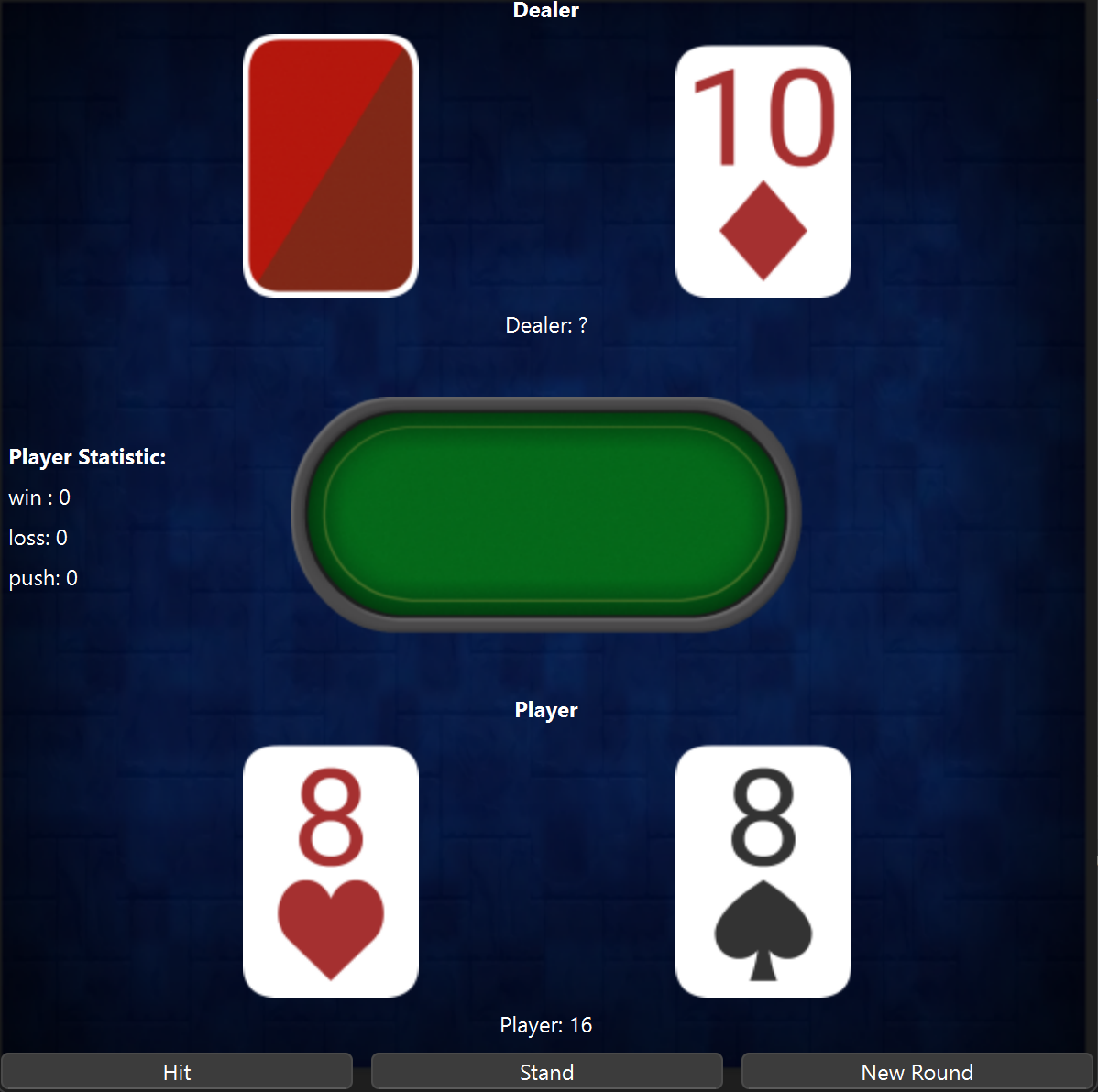
Figure 1 Start game initial window
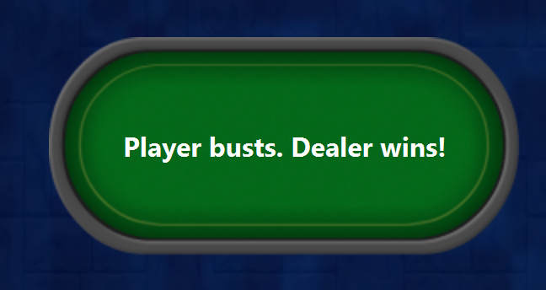
Figure 2 Win/Loss status

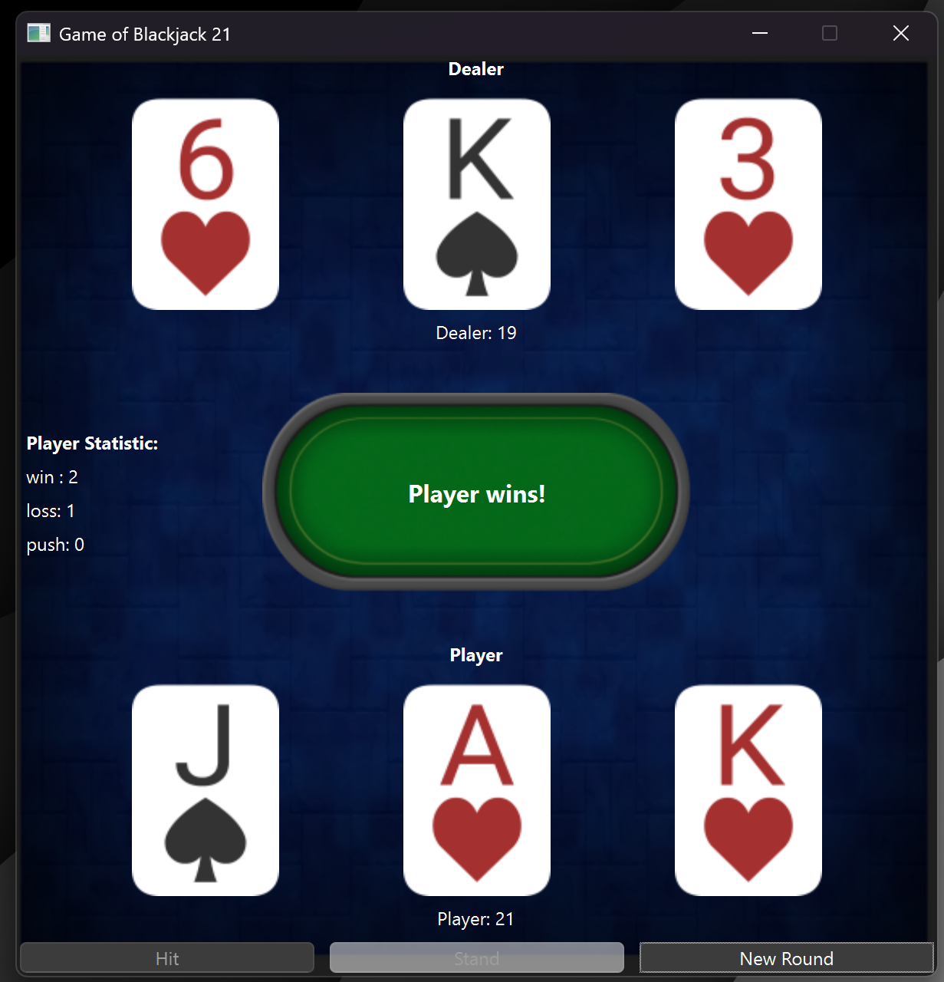
Figure 3 Winning hand with Card draws
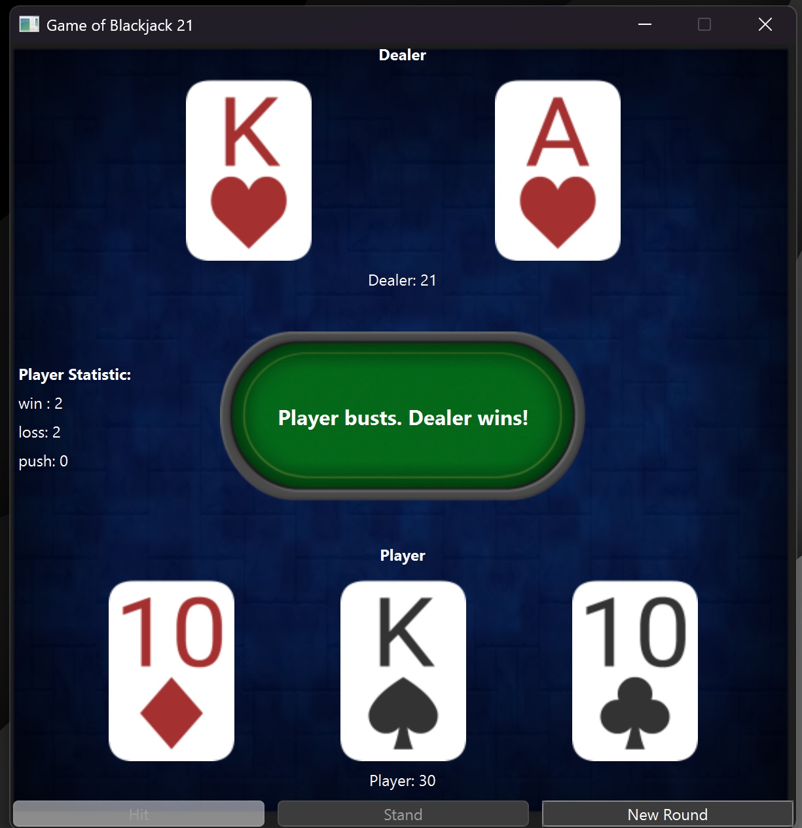
Figure 4 Losing hand
This game is straightforward to manage. There are two sets of cards top and bottom where dealer is at the top and player at the bottom. We have also decided place the hit, stand and new game button at the bottom of the players card for easy and we do not need to move our eyes.
Figure 5 controls

The extra feature which is the player statistics is place on the middle left for clear and easy to read. The cards points is also displayed on the bottom of both sets of cards. Lastly the win status would be displace in the middle of the window in the casino table.


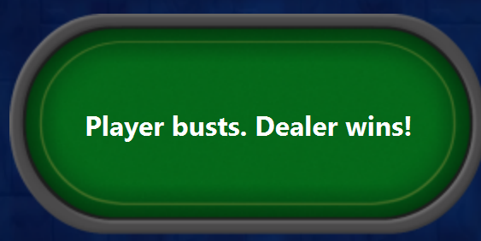
Figure 6 Player Cards Points
Figure 7 Dealer card points
Figure 8 win status

We went with a mainstream color which is a dark blue background, Green casino Table in the, Red card decks and white face so it is easy to scan with the dark background.

We have used a few Gestalt principles:
Proximity:
Player and dealer cards are grouped together at the top and bottom

Similarity:
All cards share the same shapes colour and style

Figure-Ground:
High contrast between the elements and the dark blue background. The cars and text clearly stand out

Neilsen’s Usability Heuristics:
Visibility of System Status:
The game clearly show Player: points, Dealer: ? and player statistic. Which has a immediate respond time after a action

Match between System and The Real World:
Real world casino logics is followed. Dealer cards at the top, player cards at the bottom. One of the dealer cards are faced down until the player has finish hitting and stood. Card values and pattern is also uses the conventional way.
The assets I used for the card, background and table images are from this link
https://natomarcacini.itch.io/card-asset-pack

